- INTRODUCTION

The rapid growth of the Internet of Things (IoT) has revolutionised the way physical parameters are monitored and controlled in real time. IoT systems combine embedded hardware, wireless communication, cloud computing, and mobile applications to build intelligent networks that operate continuously without human intervention. Among the most critical applications of IoT are environmental safety systems particularly those focused on water level monitoring and gas leakage detection where timely automated alerts can prevent property damage, resource wastage, and loss of life.
This project titled "Design and Development of a LoRa-Based IoT Network for Smart Application," presents the design and implementation of a wireless sensor network for two safety-critical applications: water level monitoring using the HC-SR04 ultrasonic sensor, and gas leakage detection using the MQ-2 gas sensor. The system uses LoRa (Long Range) wireless communication technology implemented through the Reyax RYLR998 module to transmit sensor data over long distances at very low power — a significant advantage over conventional short-range wireless protocols such as Wi-Fi and Bluetooth.
The system consists of two independent ESP32-WROOM 38-pin microcontroller nodes. The transmitter node reads the HC-SR04 and MQ-2 sensors, processes the raw data into distance, water level percentage, and gas concentration percentage, and transmits this data wirelessly via the RYLR998 LoRa module using the SPI interface. The receiver node decodes the incoming LoRa packet and drives three simultaneous outputs: a 16×2 LCD display showing real-time sensor values via I2C, an active buzzer alarm triggered when water level exceeds 90% or gas concentration exceeds the safety threshold, and a Wi-Fi uplink to the Blynk IoT cloud platform for remote monitoring through the Blynk mobile application and web console. Both nodes are independently powered by a 230V AC to 5V DC regulated power supply circuit designed using a step-down transformer, IN4007 bridge rectifier, 1000 µF filter capacitor, and LM7805 voltage regulator.

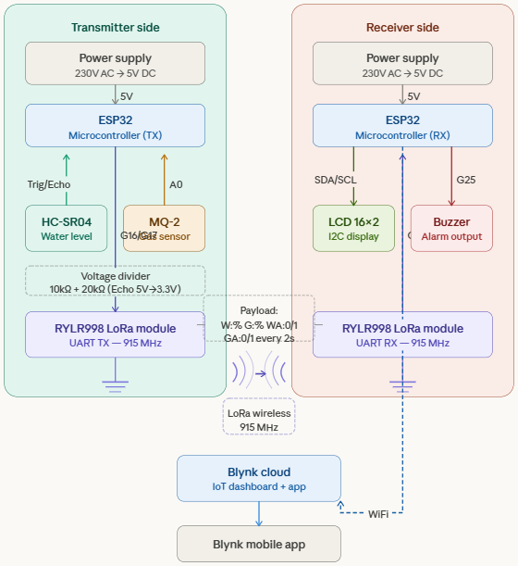

Fig: 1.1 Block Diagram of Long Range communication System

2. LITERATURE SURVEY

2.1 Literature Survey
The development of IoT networks has rapidly advanced over the past decade, with numerous studies exploring efficient communication technologies for environmental monitoring, industrial safety, and smart city applications. Among these, LoRa (Long Range) has emerged as a prominent solution due to its low-power consumption, long-range communication, and robustness in challenging environments.
2.1.1 LoRa Technology
LoRa is a wireless modulation technique that operates in the sub-GHz ISM bands, enabling devices to transmit data over several kilometers while maintaining extremely low power consumption. Compared to traditional communication protocols like Wi-Fi, Bluetooth, or ZigBee, LoRa offers superior range and scalability, making it ideal for wide-area IoT networks. Studies have shown that LoRa can maintain high packet delivery rates in both urban and rural environments, supporting multiple sensor nodes with minimal interference.
2.1.2 LoRa in Environmental Monitoring
Several research works have demonstrated the effectiveness of LoRa-based networks for environmental sensing. For instance, LoRa-enabled water level monitoring systems have been deployed to track reservoirs, rivers, and urban drainage systems, providing real-time data for flood prevention and efficient water management. The ability of LoRa nodes to transmit data over long distances allows sensors to be installed in remote locations without requiring complex infrastructure.
2.1.3 LoRa in Safety Applications
LoRa has also been successfully used for industrial safety monitoring, including gas leak detection. Systems using LoRa transmit hazardous gas data from remote sensors to a centralized monitoring station, enabling early warning and timely intervention. This approach reduces reliance on wired networks and allows deployment in hazardous or difficult-to-access areas, ensuring safety and operational efficiency.
2.1.4 Multi-Application LoRa Networks
Modern IoT deployments increasingly require networks that support multiple applications simultaneously. Research indicates that LoRa networks can effectively handle data from diverse sensor types (e.g., water level, gas concentration, temperature, humidity) in a single, unified network, reducing cost and complexity while maintaining reliable communication.
Table 2.2 : Literature Survey
Sr. No | Name of Author | Name of Research Paper | Publication Name | Year | Technique Used
1 | Jiang, Z., He, Y., Luo, B., Du, H. | "LoRa Communication for Agriculture 4.0: Opportunities, Challenges, and Future Directions" | arXiv preprint arXiv:2409.11200 | 2024 | LoRa network deployment in agricultural IoT, water tank level monitoring, multi-node star topology, energy harvesting
2 | Shanmuga Sundaram, J. P., Du, W., Zhao, Z. | "A Survey on LoRa Networking: Research Problems, Current Solutions and Open Issues" | IEEE Communications Surveys and Tutorials, Vol. 22, Issue 1, Pages 371–388 | 2020 | LoRa MAC layer, LoRaWAN Class A/B/C device operation, collision avoidance, network coverage optimisation
3 | Kufakunesu, R., Hancke, G. P., Abu-Mahfouz, A. M. | "A Survey on Adaptive Data Rate Optimisation in LoRaWAN: Recent Solutions and Open Issues" | MDPI Sensors, Vol. 20, Issue 3, Article 822 | 2020 | Adaptive data rate (ADR) algorithms, spreading factor optimisation, throughput maximisation in LoRa networks
4 | Islam, M. A., Dang, L. M., Baik, S., Moon, H. | "IoT-Based Water Level Monitoring System Using LoRa Communication" | International Journal of Advanced Computer Science and Applications (IJACSA), Vol. 11, Issue 3 | 2020 | JSN-SR04T ultrasonic sensor, LoRa SX1276 module, ESP32 interfacing, water tank level measurement and alert
5 | Noura, M., Atiquzzaman, M., Gaedke, M. | "Interoperability in Internet of Things: Taxonomies and Open Challenges" | Mobile Networks and Applications, Springer, Vol. | 2019 | IoT interoperability framework, protocol comparison (MQTT, CoAP, HTTP), cloud platform integration
3. SYSTEM DESIGN AND OVERVIEW

3.1 System Design
The proposed system is a LoRa-based smart monitoring system designed to detect gas leakage and monitor water level in real time. The system consists of two main units: a transmitter unit and a receiver unit. The transmitter unit collects data from sensors, while the receiver unit processes the data and provides alerts and display output.
The system also integrates IoT technology using the Blynk platform, allowing remote monitoring through a mobile application.

The system is divided into two parts:
3.1.1 Transmitter Unit
The transmitter unit consists of an ESP32 microcontroller connected to the MQ-2 gas sensor and the HC-SR04 water level sensor. The ESP32 reads sensor data and sends it to the LoRa module (RYLR998), which transmits the data wirelessly.
3.1.2 Receiver Unit
The receiver unit consists of another ESP32 connected to a LoRa module, buzzer, and display. The LoRa module receives the transmitted data and sends it to the ESP32. Based on the received data, the ESP32 activates the buzzer in case of gas leakage or high water level and displays the information on the screen.
Additionally, the ESP32 connects to WiFi and uploads the data to the Blynk cloud, enabling remote monitoring.

3.1.3 Working Principle
The system works by continuously monitoring environmental conditions using sensors. When gas leakage or high water level is detected, the data is transmitted via LoRa to the receiver unit. The receiver processes the data, triggers alerts, displays information, and sends data to the cloud for remote access.

3.2 Workflow
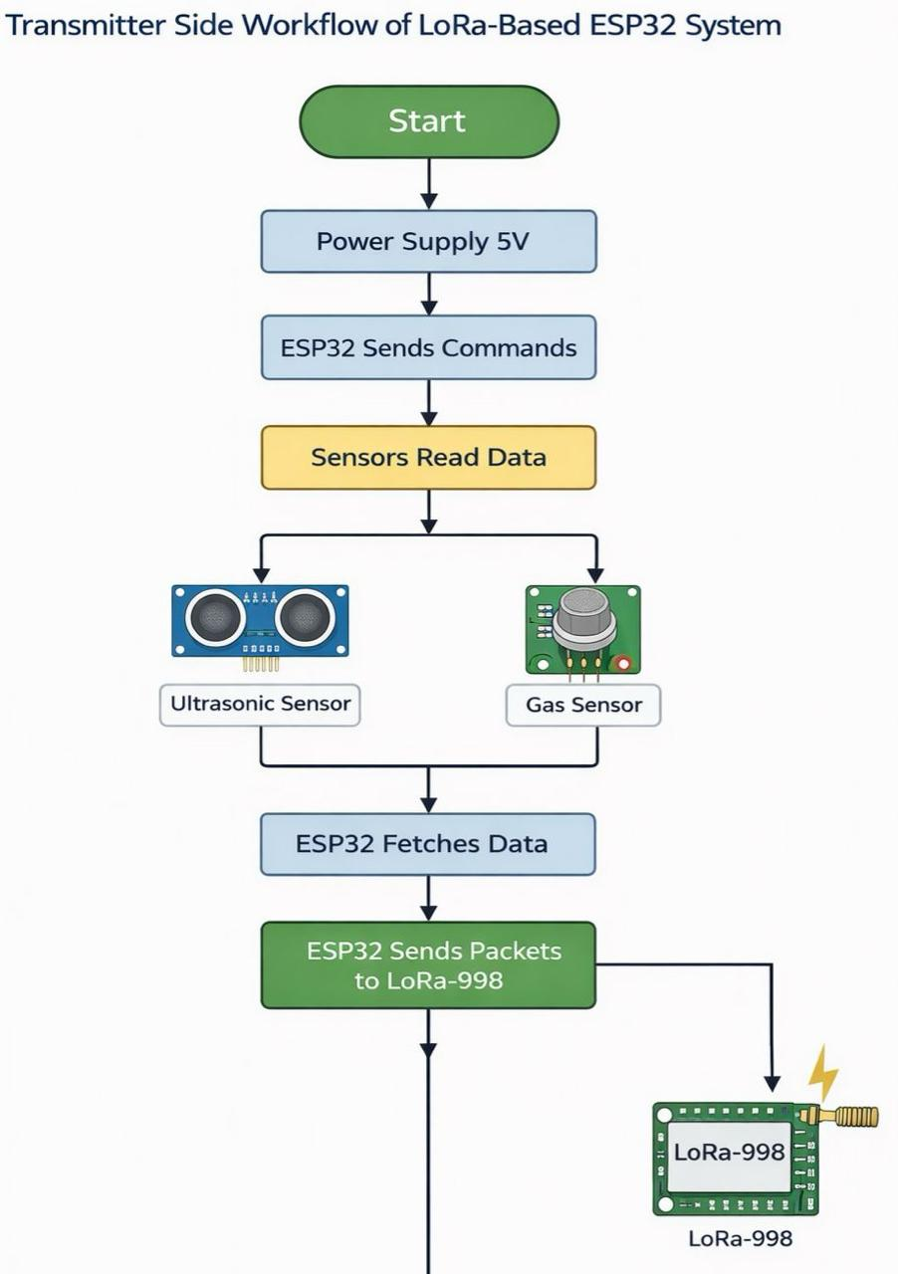
3.2.1. Transmitter Workflow

Figure. 3.2.1 : Block Diagram of LoRa System Workflow ( Transmitter)

3.2.2. Receiver Workflow
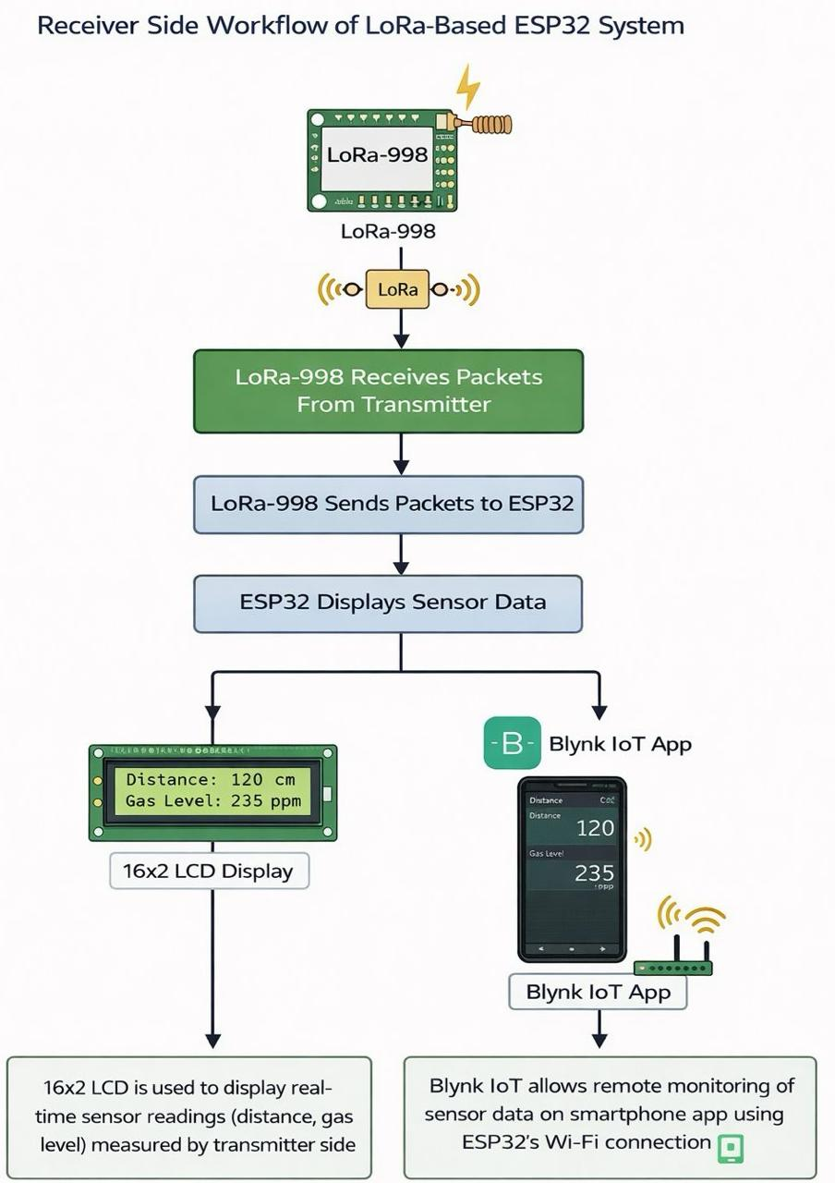

Figure 3.2.2: Block Diagram of LoRa System Workflow ( Receiver )

3.3 Core component
3.3.1 Gas Sensor (MQ-2)
In the proposed system, the MQ-2 gas sensor is used to detect the presence of combustible gases such as LPG, methane, and smoke.
The sensor operates based on the principle of change in resistance of tin dioxide (SnO₂) when exposed to gas. Under normal conditions (clean air), the sensor exhibits high resistance. When gas is detected, the resistance decreases, resulting in a change in output voltage.
This analog voltage output is connected to the ESP32 microcontroller. The ESP32 continuously reads the sensor value using its ADC (Analog-to-Digital Converter).
- If the gas concentration is below threshold → Normal condition
- If the gas concentration is above threshold → Gas leakage detected Once gas is detected:
- ESP32 sends data to the LoRa module (RYLR998)
- Data is transmitted wirelessly to the receiver

- At the receiver:
  - Buzzer is activated
  - LCD displays alert message
  - Data is sent to the Blynk cloud for remote monitoring

The MQ-2 sensor plays a critical role in ensuring safety by enabling early detection of gas leakage.

Features:
- Detects multiple gases (LPG, methane, smoke)
- High sensitivity
- Fast response time
- Analog and digital output
- Simple interfacing with microcontrollers
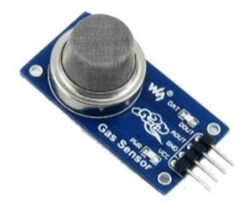
- Low cost and easily available
Image 3.3.1: MQ-2 Gas Sensor
3.3.2 Ultrasonic Sensor (HC-SR04)

The HC-SR04 is an ultrasonic sensor used to measure distance using sound waves. It is commonly used for distance and level measurement in embedded systems.

In this project, the HC-SR04 sensor is used to measure water level. It sends ultrasonic waves toward the water surface and receives the reflected waves. The ESP32 calculates the distance using echo time and determines the water level. If the level is high, data is sent via LoRa, the buzzer is activated, the display shows the level, and data is uploaded to the Blynk cloud.

It is used because it is simple, low-cost, and provides accurate distance measurement. It is easy to interface with microcontrollers like ESP32.

Features
- Non-contact measurement
- High accuracy
- Easy interfacing
- Low cost

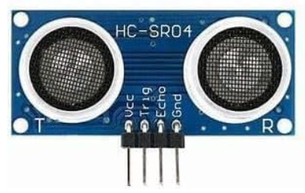
Image 3.3.2 : Ultrasonic Sensor (HC –SR04)

3.3.3 LoRa module ( REYAX RYLR 998).
The REYAX RYLR998 is a LoRa-based wireless communication module used for long-range, low-power data transmission. It operates using LoRa (Long Range) technology, which is suitable for IoT applications requiring communication over large distances.
In this project, two RYLR998 modules are used for wireless communication.
- Transmitter Side:
  - ESP32 sends sensor data (gas and water level) to the LoRa module
  - LoRa module transmits the data wirelessly
- Receiver Side:
  - LoRa module receives the transmitted data
  - Sends data to ESP32 for processing
  - ESP32 activates buzzer, displays data on LCD, and sends data to the Blynk cloud
Features
- Long-range communication (several kilometers)
- Low power consumption (3.3 V)
- Works without internet (LoRa technology)
- High sensitivity and reliable transmission
- UART (serial) interface for easy connection
- Compact and easy to integrate
- Suitable for IoT and monitoring systems

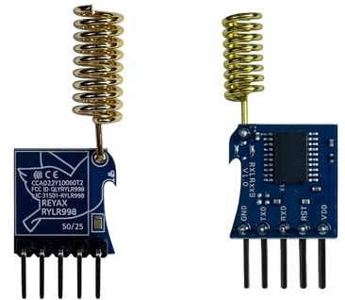
Image 3.3.3 : LoRa Module (RYLR998)
3.3.4 ESP32 WROOM
The ESP32 (38-pin) is a powerful microcontroller with built-in WiFi and Bluetooth capabilities. It has a large number of GPIO pins, making it suitable for complex IoT and embedded system applications.
In this project, ESP32 (38-pin) is used on both transmitter and receiver sides.
- Transmitter Side:
  - Reads data from MQ-2 gas sensor and HC-SR04 water level sensor
  - Processes sensor data
  - Sends data to LoRa module (RYLR998) using UART
- Receiver Side:
  - Receives data from LoRa module
  - Processes received data
  - Activates buzzer during alert conditions
  - Displays data on LCD
  - Sends data to the Blynk cloud via WiFi
Features
- Built-in WiFi and Bluetooth for IoT (Blynk integration)
- Large number of GPIO pins (38-pin version supports more connections)
- Supports analog and digital inputs
- Supports multiple communication protocols (UART, I2C, SPI)
- High processing speed
- Suitable for handling multiple sensors and modules
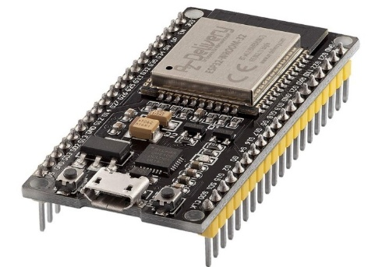
Image 3.3.4 : ESP 32 Microcontroller
3.3.5 Active Alarm Buzzer
The active buzzer is an electronic sound-producing device that generates a beep sound when power is applied. It has an internal oscillator, so it does not require any external signal to produce sound.

In this project, the active buzzer is connected to the ESP32 at the receiver side. When the system detects gas leakage or a high water level condition, the ESP32 sends a signal to the buzzer. The buzzer then produces an audible alarm to alert the user.

The active buzzer is used because it is simple to operate, requires no external signal generation, and provides an immediate audio alert during emergency conditions.
Features
- The active buzzer has a built-in oscillator
- It generates a continuous beep sound when power is applied.
- It has a simple ON/OFF control
- It operates at a low voltage (3.3V to 5V),
- It has low power consumption,
- It is compact and lightweight,
- It provides a quick audio alert,

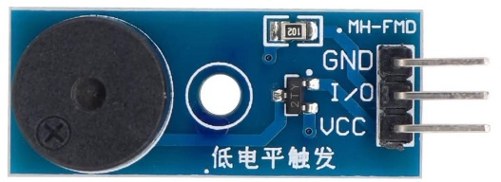

Image 3.3.5 : Active Alarm Buzzer

3.3.6 LCD Display
The LCD (Liquid Crystal Display) is an electronic display module used to show text and basic data. It is commonly used in embedded systems for displaying information.

In this project, the LCD display is connected to the ESP32 at the receiver side. It is used to display real-time data such as gas detection status and water level. The ESP32 sends data to the LCD, and the display shows the information for local monitoring.

The LCD display is used because it provides a simple and clear way to display system data. It allows users to easily monitor gas leakage and water level without using a mobile device.
Features
- Low power consumption
- Displays text and basic data
- Easy to interface with microcontrollers
- Supports 16×2 character display
- Compact and lightweight
- Clear and readable output

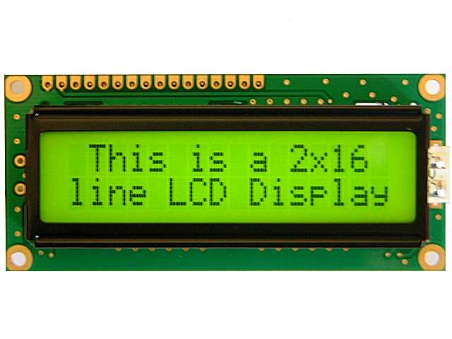
Image 3.3.6 : LCD Display

3.3.7 Power Supply
The power supply is designed to convert 230V AC mains voltage into a regulated 5V DC output required for the system components.
The power supply works in the following stages:
- Step-Down Transformer: Reduces 230V AC to 12V AC voltage
- Rectifier: Converts AC voltage into pulsating DC using a bridge rectifier.
- Filter: Removes ripples using a capacitor to obtain smooth DC.
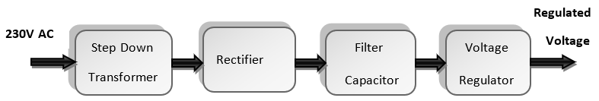
- Voltage Regulator: Regulates the output to a constant 5V DC using a regulator (e.g., 7805).
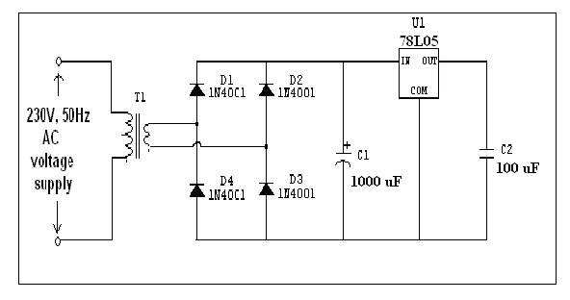
Figure : 3.3.7: Block diagram of power supply
Figure 3.3.8: design for 5v power supply
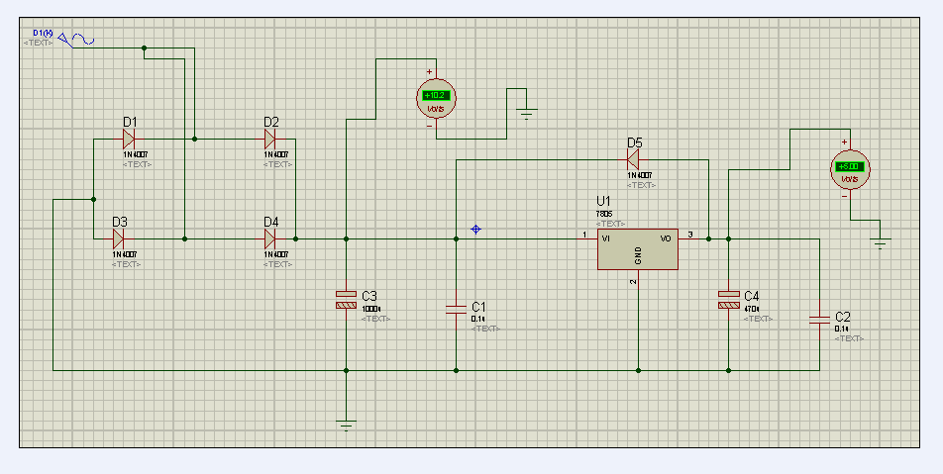
Figure 3.3.9 : Power Supply Simulation
4. SYSTEM IMPLEMENTATION ( HARDWARE )

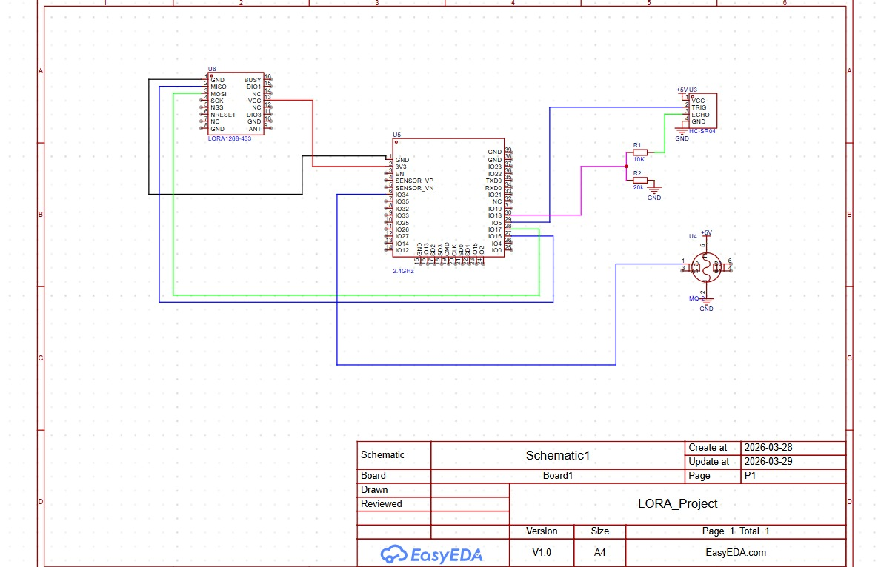
4.1 Transmitter Circuit Diagram :
Figure 4.1:- Circuit Diagram of Transmitter Node
4.1.1. Power Supply
- Input: 230V AC mains supply
- Output: 5V DC
- 5V DC connected to:
  - ESP32 (5V pin)
  - Sensors (HC-SR04, MQ-2)
- GND is common for all components
The power supply unit converts high voltage 230V AC into regulated 5V DC, which is required for operating the ESP32 and peripheral devices. It ensures stable and continuous power to both transmitter and receiver circuits.

4.1.2. ESP32
Connections:
- 5V → 5V pin
- GND → GND
- GPIO 5 → Ultrasonic TRIG
- GPIO 18 → Ultrasonic ECHO (via voltage divider)
- GPIO 34 → MQ-2 (A0)
- GPIO 16 → LoRa RX
- GPIO 17 → LoRa TX
Function:
ESP32 acts as the main controller. It reads data from sensors, processes it, and transmits it through the LoRa module.

4.1.3. Ultrasonic Sensor (HC-SR04)
Connections:
- VCC → 5V
- GND → GND
- TRIG → GPIO 5
- ECHO → GPIO 18 (via voltage divider)
- Echo pin → 1kΩ resistor → GPIO 18
- Between GPIO 18 and GND → 2kΩ resistor
Function:
The ultrasonic sensor measures the distance between sensor and water surface, which is used to calculate water level.

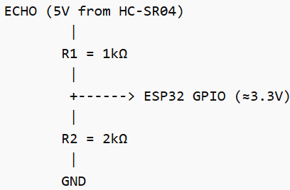
4.1.4. Voltage Divider circuit
- Echo pin → 1kΩ resistor → GPIO 18
- Between GPIO 18 and GND → 2kΩ resistor
- The voltage divider reduces the 5V Echo signal to 3.3V, which protects the ESP32 GPIO pin from damage.

4.1.5. MQ-2 Gas Sensor
Connections:
- VCC → 5V
- GND → GND
- A0 → GPIO 34

Function:
The MQ-2 sensor detects gases like LPG, smoke, and methane and provides an analog output corresponding to gas concentration.

4.1.6. LoRa Module (REYAX RYLR998 - Transmitter)
Connections:
- VDD → 3.3V
- GND → GND
- TX → GPIO 16
- RX → GPIO 17
Function:
The LoRa module transmits sensor data over long distances using low power wireless communication.

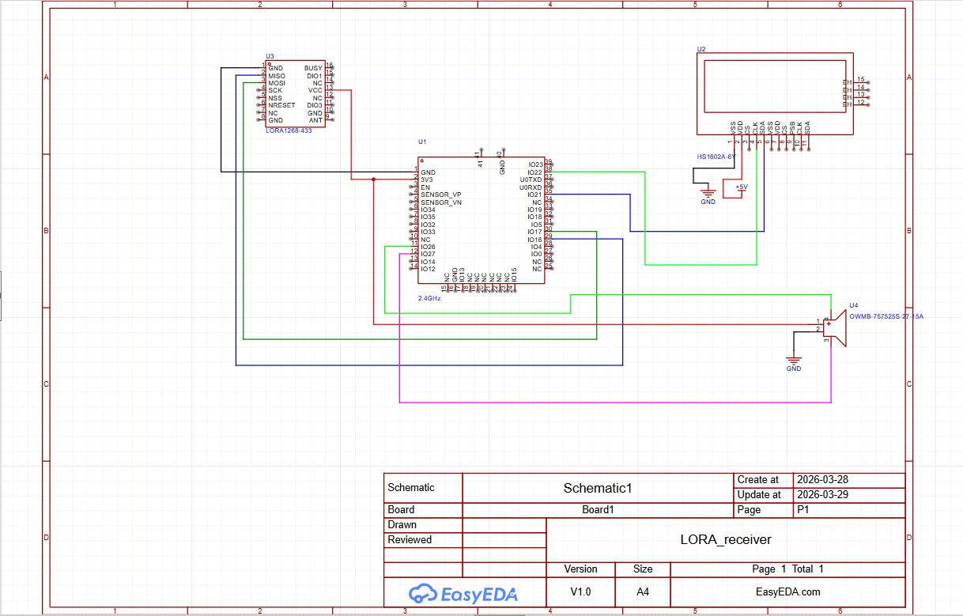
4.2 Receiver Circuit Diagram :
Figure 4.2:- Circuit Diagram of Receiver Node
4.2.1. Power Supply
- Input: 230V AC mains supply
- Output: 5V DC
- 5V DC connected to: ESP32 (5V pin), LCD display
- GND is common for all components
The power supply unit converts high voltage 230V AC into regulated 5V DC, which is required for operating the ESP32 and peripheral devices.
4.2.2. ESP 32
- 5V → 5V pin
- GPIO 16 → LoRa RX
- GPIO 17 → LoRa TX
- GPIO 21 → LCD SDA
- GPIO 22 → LCD SCL
- GPIO 25 → Buzzer
Function:
ESP32 receives data from the LoRa module, processes it, and controls output devices like LCD and buzzer.

4.2.3. LoRa Module (Receiver)
- VDD → 3.3V
- TX → GPIO 16
- RX → GPIO 17
Function:
Receives transmitted data from the transmitter LoRa module and sends it to ESP32.

4.2.4. LCD Display (16x2 I2C)
- VCC → 5V
- SDA → GPIO 21
- SCL → GPIO 22
Function:
Displays real-time data such as:
- Water level
- Gas concentration

4.2.5. Buzzer
Connections:
- VCC → 3.3V
- I/O → GPIO 25
Function:
The buzzer provides an alert signal when:
- Gas level exceeds threshold
- Water level reaches critical condition

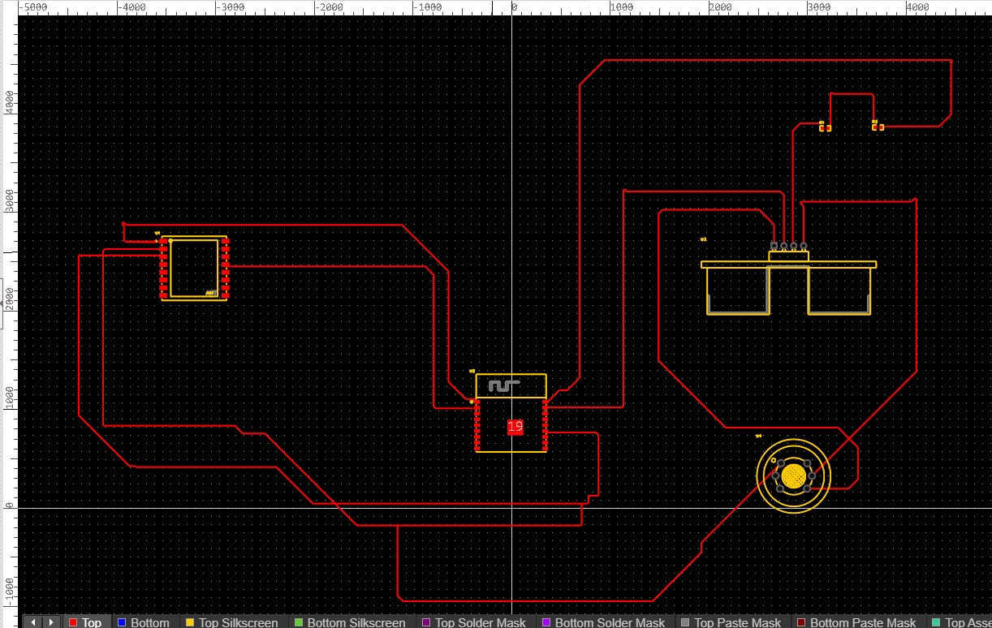
4.3 Transmitter Circuit Layout

Figure 4.3 : Transmitter Layout Of PCB Design

The transmitter PCB layout is designed using EasyEDA, with the ESP32 WROOM placed at the center as the main controller. The HC-SR04 ultrasonic sensor and MQ-2 gas sensor are connected to the ESP32 GPIO pins for water level and gas detection respectively. A voltage divider circuit using 1kΩ and 2kΩ resistors is used to protect the ESP32 Echo pin from 5V. The RYLR998 LoRa module is placed close to the ESP32 and connected via UART (GPIO 16 & 17) for wireless data transmission. The onboard power supply converts 230V AC to regulated 5V DC using a transformer, IN4007 bridge rectifier, 1000µF capacitor, and LM7805 voltage regulator.

4.4 Receiver Circuit Layout

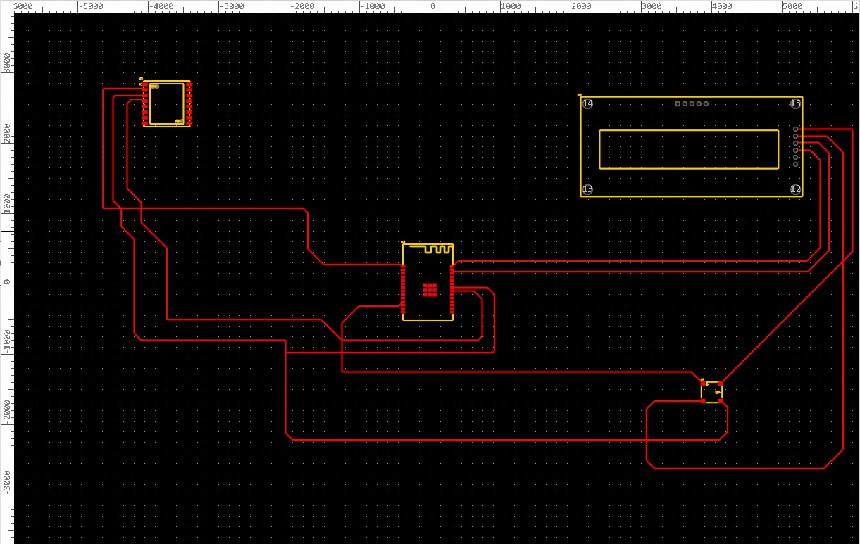

Figure 4.4: Receiver Layout Of PCB Design

The receiver PCB layout is also designed using EasyEDA with a similar power supply configuration. The ESP32 WROOM is placed at the center, connected to the RYLR998 LoRa module via UART (GPIO 16 & 17) for receiving transmitted data. A 16×2 I2C LCD display is connected via GPIO 21 (SDA) and GPIO 22 (SCL) for real-time data display, and an active buzzer is connected to GPIO 25 for audio alerts. The layout ensures short signal paths, common grounding, and proper voltage level management between 3.3V and 5V components.

4.5 Transmitter 3-D Model
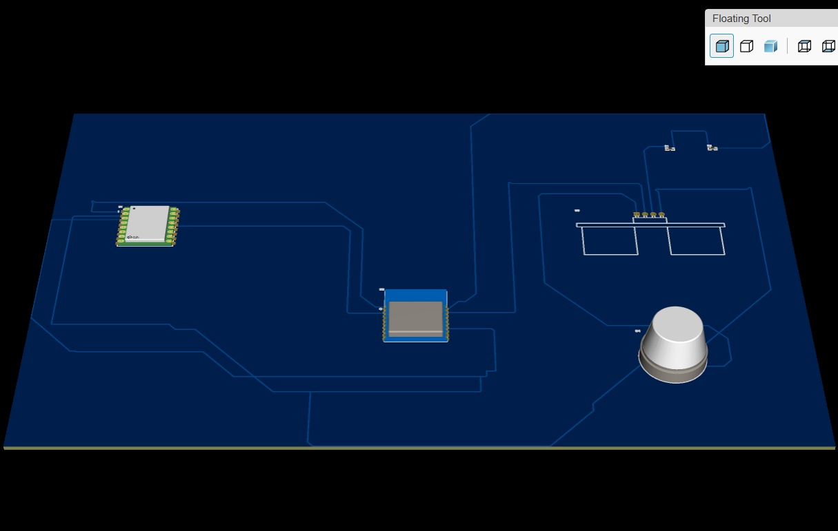
The 3D model of the transmitter PCB is generated using EasyEDA built-in 3D visualization tool. It provides a realistic physical view of the transmitter board before actual fabrication. The model clearly shows the placement of the ESP32 WROOM, HC-SR04 ultrasonic sensor, MQ-2 gas sensor, LoRa module, and power supply components on the PCB. The purpose of this 3D model is to verify that all components are correctly placed, check for any mechanical conflicts or overlapping, and ensure proper spacing between components. It helps the designer to visualize the actual size and height of each component on the board, reducing the chances of errors during physical assembly. In this project, the transmitter 3D model was used to confirm the component layout before soldering and mounting on the zero PCB board.

Figure 4.5 : Transmitter 3-D Model

4.6 Receiver 3-D Model
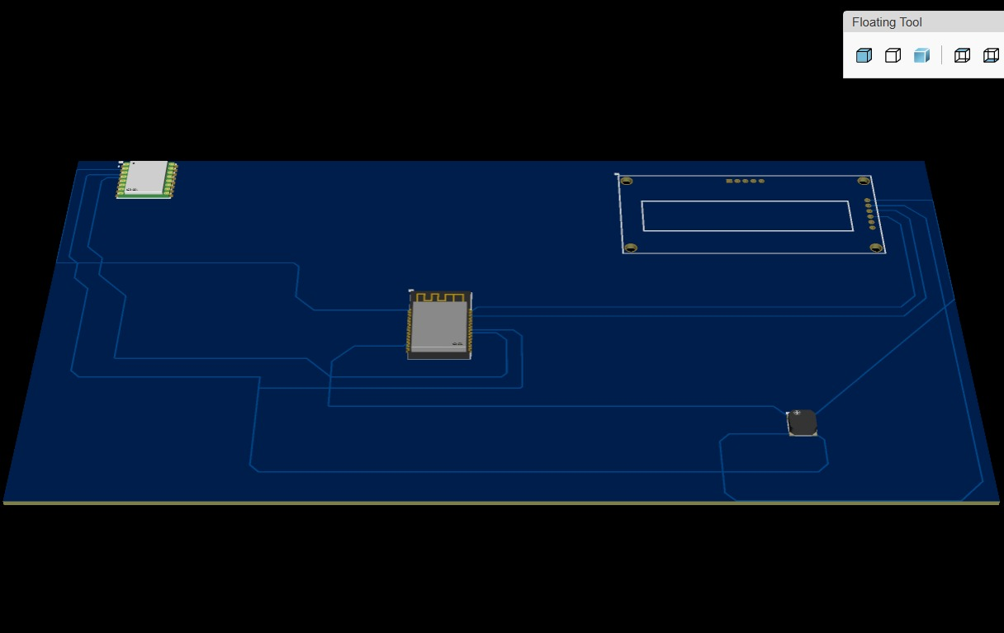
The 3D model of the receiver PCB is similarly generated using EasyEDA to provide a physical visualization of the receiver board. It displays the arrangement of the ESP32 WROOM, RYLR998 LoRa module, 16×2 LCD display, active buzzer, and power supply unit in their actual positions on the PCB. The concept behind 3D modelling is to bridge the gap between schematic design and real-world hardware implementation, allowing the designer to identify any design issues before fabrication. In this project, the receiver 3D model helped in confirming that the LCD display, buzzer, and LoRa module are properly positioned for easy accessibility and user interaction. It also ensured that the board dimensions and component heights are within acceptable limits for the final enclosure or base mounting.

Figure 4.6 : Receiver 3-D Model

4.7 After Component Mounting On PCB
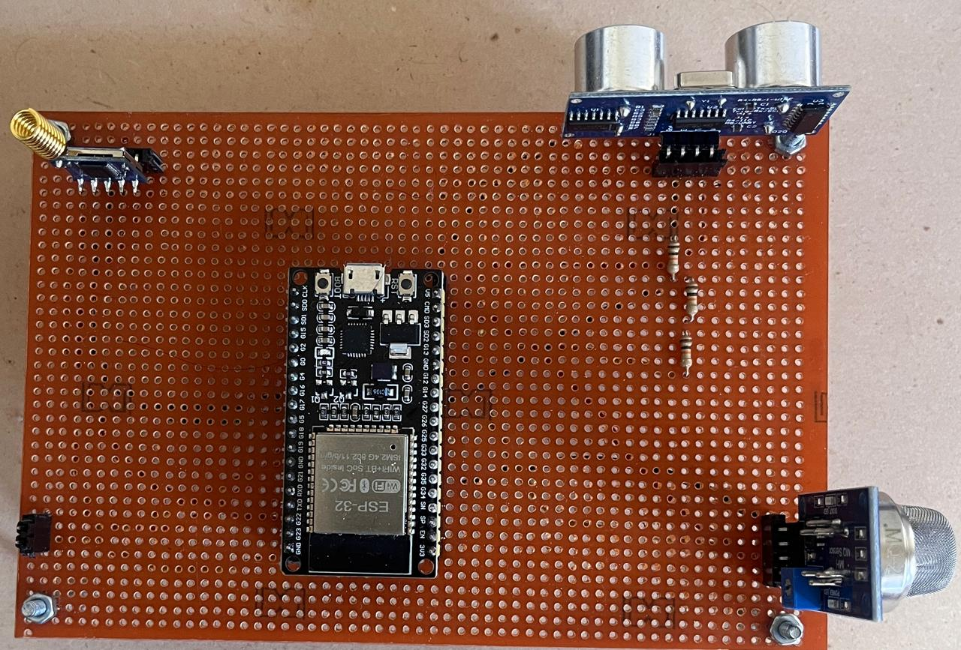
4.7.1. Transmitter

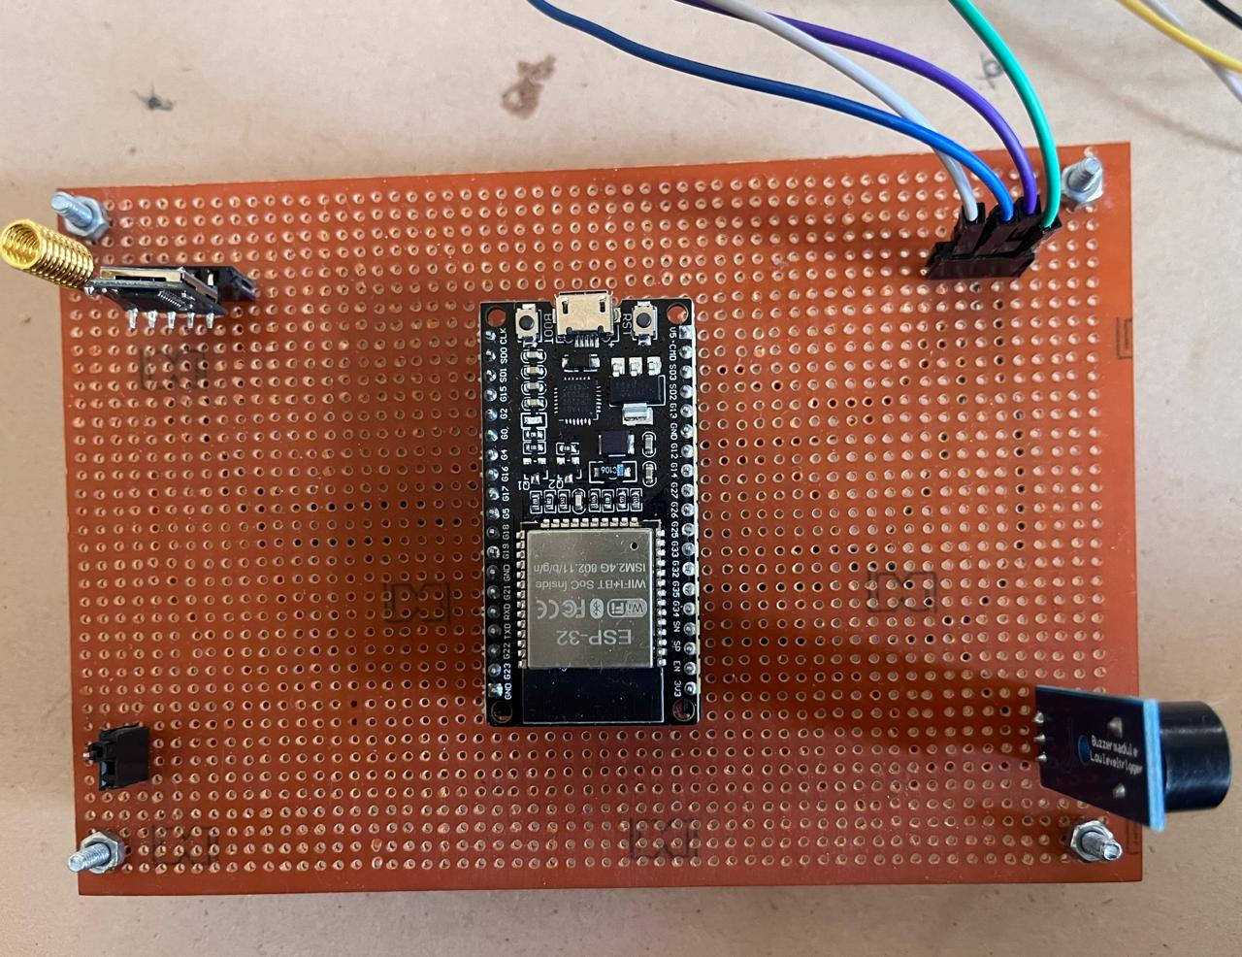
4.7.2. Receiver
Figure 4.7: After Component Mounting On PCB
4.7.1 Transmitter
The transmitter board shows the ESP32 WROOM microcontroller mounted at the center of the zero PCB, with the HC-SR04 ultrasonic sensor, MQ-2 gas sensor, and RYLR998 LoRa module properly connected through burg strip connectors and jumper wires. The voltage divider resistors and power supply components including the transformer, IN4007 bridge rectifier, filter capacitor, and LM7805 voltage regulator are neatly soldered on the board. The overall condition of the transmitter board appears clean, properly assembled, and ready for operation.

4.7.2 Receiver
The receiver board shows the ESP32 WROOM at the center with the RYLR998 LoRa module, 16×2 LCD display, and active buzzer mounted and connected through burg strip connectors. The power supply circuit is similarly assembled on the board. The overall condition of the receiver board looks well organized, with all components securely placed and connections properly made.

4.7.3 Overall Significance
This section marks the most satisfying and rewarding milestone of the entire project. After long hours of circuit design, PCB layout, 3D modelling, and component sourcing, seeing the fully assembled hardware working in real life is the moment that validates all the effort and hard work put into the project. Both boards together represent the complete hardware implementation of the LoRa-based IoT monitoring system, ready for software uploading, testing, and final performance analysis.

- SYSTEM IMPLEMENTATION (SOFTWARE)

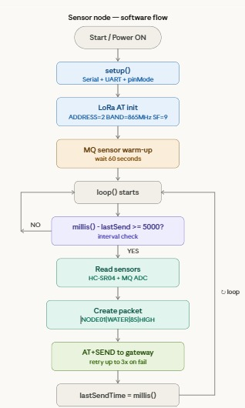
5.1 Transmitter Data Flowchart
Figure 5.1 : Data Flowchart Transmitter
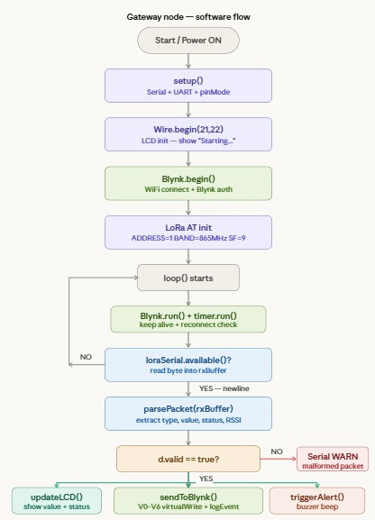
5.2 Receiver Data Flowchart
Figure 5.2 : Data Flowchart Receiver
5.3. Importance of Software Analysis
The software of the proposed LoRa-based smart monitoring system is designed to perform data acquisition, processing, wireless transmission, and alert generation. The complete system is divided into two main parts: the sensor node (transmitter) and the gateway node (receiver). Both nodes are programmed using the Arduino IDE and ESP32 libraries. Communication between the nodes is achieved using LoRa modules configured through AT commands via UART interface.
5.3.1. Software Analysis (Transmitter)
When the system is powered ON, the ESP32 initializes serial communication, GPIO pins, and the LoRa module using AT commands. The MQ-2 gas sensor is given a warm-up time of about 60 seconds for accurate readings.
In the loop function, the system checks the time interval using the millis() function and sends data every 5 seconds. The ESP32 reads data from the ultrasonic sensor to measure water level and from the MQ-2 sensor to detect gas concentration.
The collected data is processed and converted into a structured data packet containing node ID, parameter, value, and status. This data is then transmitted to the receiver using the LoRa module. If transmission fails, the system retries up to three times.
5.3.2. Software Analysis (Receiver)
After power ON, the ESP32 initializes serial communication, LoRa module, and LCD display. It also connects to Wi-Fi and initializes the Blynk platform for remote monitoring.
In the loop function, the system continuously checks for incoming data from the LoRa module. When data is received, it is stored, parsed, and validated.
If the data is valid, it is displayed on the LCD screen and sent to the Blynk application. If the sensor values exceed threshold limits, the buzzer is activated to provide an alert. If the data is invalid, a warning message is displayed.

6. COMPONENT LIST
Table 6.1 List of Components
Sr.No. | Component name | Specifications | Quantity | Cost
1 | ESP32 | WROOM 32 | 2 | Rs.860
2 | Ultrasonic Sensor | HC-SR04 | 1 | Rs.90
3 | LoRa Module | RYLR998 | 2 | Rs.4275
4 | MQ-2 Gas Sensor | MQ-2 | 1 | Rs.180
5 | Burg strip | Male, Female | 5 | Rs.100
6 | LCD Display | 16×2 LCD | 1 | Rs.220
7 | Zero PCB Board | 10 ×15 mm | 2 | Rs.120
8 | Jumper Wires | Connecting wire | 10 | Rs.100
9 | Resistors | 1K, 2K | 3 | Rs.10
10 | Buzzer | Active Buzzer | 1 | Rs.180
11 | Acrylic Sheet Base | 50 mm | 2 | Rs.120
12 | Transformer | Step Down | 2 | Rs.208
13 | Diode Bridge | IN4007 | 2 | Rs.30
14 | Capacitors | 1000 µF | 2 | Rs.20
15 | Voltage Regulator | 7805 | 2 | Rs.30
 |  |  | Total | Rs.6,543

    - PERFORMANCE ANALYSIS
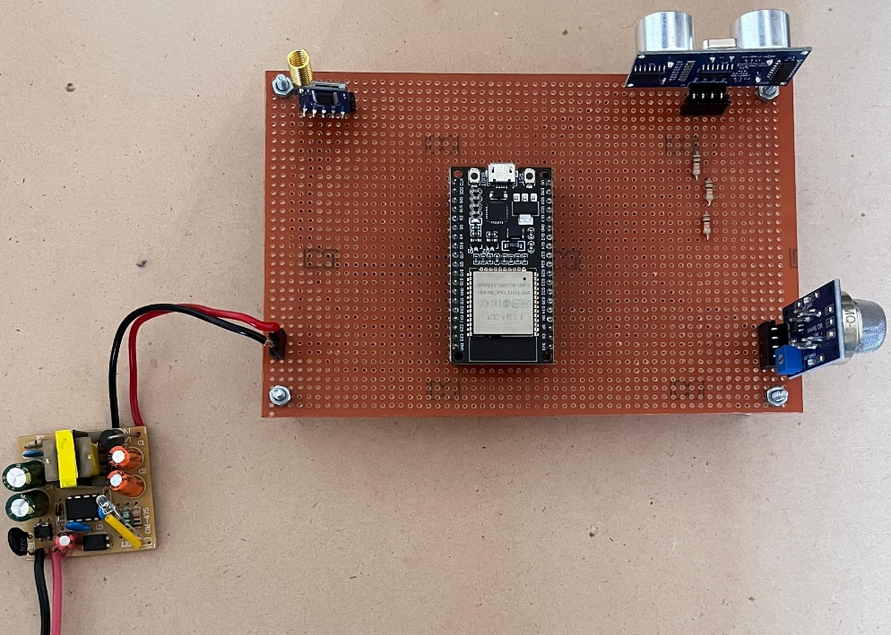
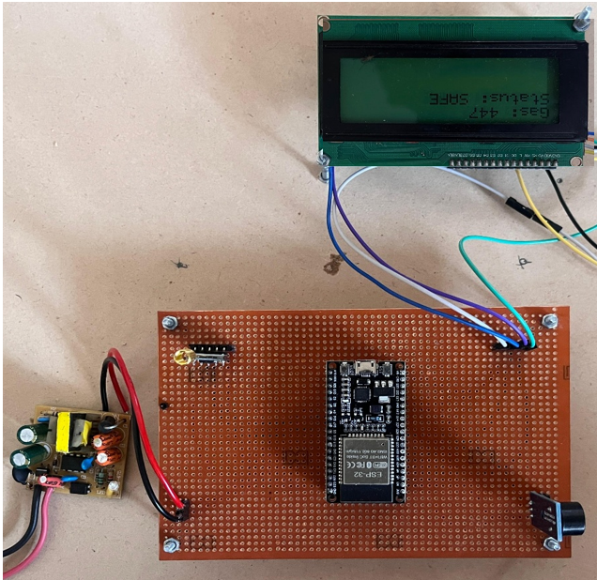
7.1 Project Model

Image 7.1 : Project Model
7.1 Project Model
The project model represents the complete and fully functional assembled system of the LoRa-based IoT network for smart monitoring, with both the transmitter and receiver units mounted on an acrylic sheet base and independently powered by a 230V AC to 5V DC regulated supply circuit.
7.1.1 Power ON & System Boot
The moment 230V AC mains supply is connected, the LM7805 voltage regulator instantly converts it to stable 5V DC. The ESP32 on both sides boots up within 1 to 2 seconds, initializes all GPIO pins, UART communication and ADC channels, and prepares itself for continuous operation silently and invisibly inside the chip.
7.1.2 Transmitter — Sensing & Processing
Once booted, the transmitter ESP32 enters a continuous loop of operation. The HC-SR04 ultrasonic sensor fires pulses toward the water surface and the ESP32 calculates the distance using echo time and converts it into a water level percentage. Simultaneously the MQ-2 gas sensor monitors the surrounding air and when gas molecules contact its tin dioxide surface, the resistance drops and the ESP32 reads this through its 12-bit ADC on GPIO 34, converting it into a gas concentration percentage. Both values are packaged into a structured data packet every 5 seconds for wireless transmission.
7.1.3 Invisible LoRa Communication
The ESP32 sends the data packet to the RYLR998 LoRa module via UART which modulates it using Chirp Spread Spectrum technology and transmits it over the 865 to 867 MHz ISM frequency band, covering several kilometers without any internet or Wi-Fi infrastructure, silently and continuously, completely invisible to the human eye.
7.1.4 Receiver — Decoding & Output
The receiver RYLR998 LoRa module constantly listens on the same frequency channel. The moment it detects an incoming packet it demodulates the signal, passes the data to the receiver ESP32 via UART, which then parses, validates and extracts the water level and gas concentration values instantly for further output processing.

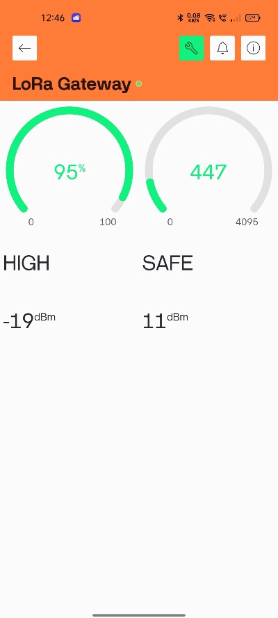
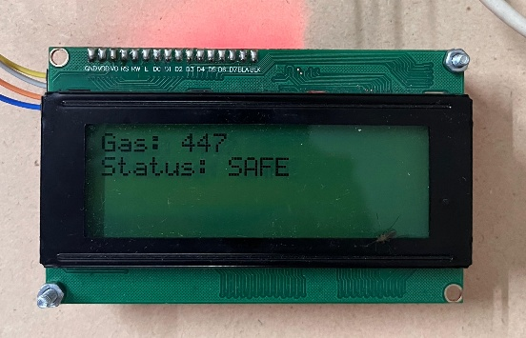
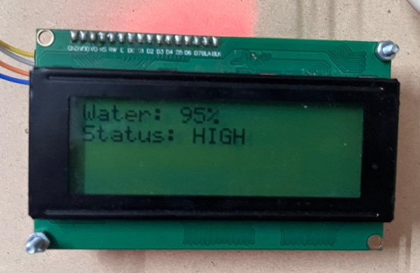
7.2 Results Blynk App & LCD Display
Image 7.2: Results Blynk App and LCD Display

7.2.1 LCD Display Output
The extracted sensor values are instantly sent to the 16×2 LCD display via I2C protocol on GPIO 21 and GPIO 22. The LCD shows the water level percentage on the first line and gas concentration percentage on the second line, refreshing in real time with every new data packet received. Under normal conditions the LCD displays safe readings with their respective percentage values. When the water level exceeds 90% or the gas concentration crosses the safety threshold the LCD immediately updates to show an alert message indicating the danger condition. This gives the user a clear and instant local visual indication of the complete system status without needing any mobile device or internet connection.
7.2.2 Buzzer Alert Output
If any unsafe condition is detected, the ESP32 immediately drives GPIO 25 HIGH, activating the active buzzer which produces a continuous beep sound. This local audio alert immediately notifies the user about gas leakage or critically high water level, adding an important physical layer of safety to the system alongside the visual LCD output.
7.2.3 Blynk Mobile Application Output
Simultaneously the receiver ESP32 uses its built-in Wi-Fi module to connect to the internet and push the sensor data to the Blynk IoT cloud platform in real time. The Blynk mobile application displays dedicated widgets showing the live water level and gas concentration percentages updating continuously with every new data received. When any parameter crosses the defined threshold limit the Blynk app triggers a remote notification alert on the user's smartphone, enabling complete awareness of any unsafe condition even when the user is far away from the physical system.
7.2.4 Overall Result Validation
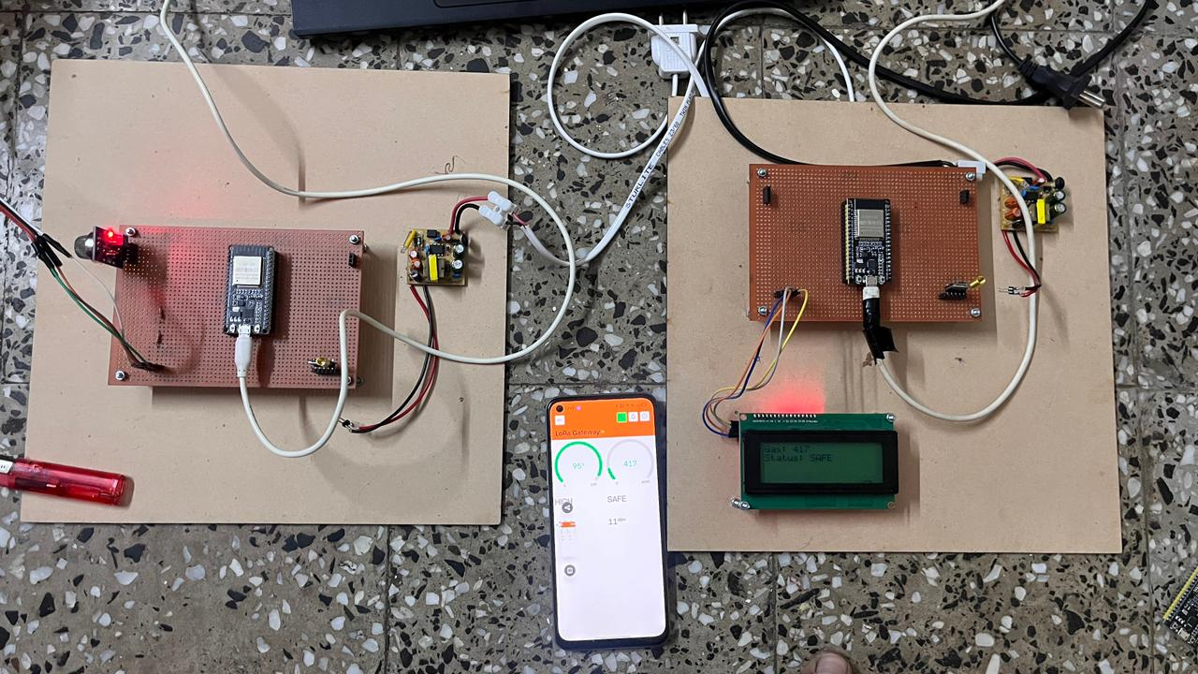
The results successfully validate the complete working of the project. All three output mechanisms, the LCD display, the active buzzer and the Blynk mobile application, work together simultaneously and reliably. The system accurately reads sensor data, transmits it wirelessly over long range using LoRa, displays real-time values locally on the LCD, triggers immediate buzzer alerts during unsafe conditions and uploads data to the Blynk cloud for remote monitoring, successfully achieving all the intended objectives of the project.
Image 7.3: Project Working results
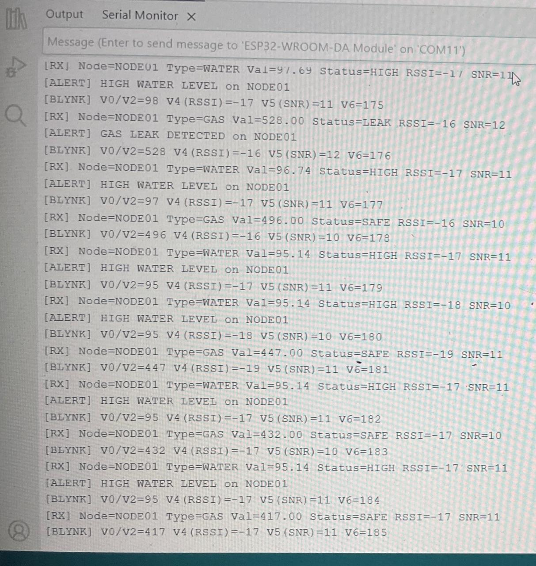
7.3 Terminal output (Receiver)
Image 7.4: Terminal output (Receiver)

The output is from an ESP32-based IoT system where NODE01 monitors water level and gas. The [RX] lines show sensor data, including value, status, and signal quality. When the water level is high (around 95–97), the system generates alerts, and when gas values are high, it detects a leak.
The [BLYNK] lines show that data is sent to the Blynk app for real-time monitoring. The water level stays high, while the gas level first shows a leak and later becomes safe. The RSSI and SNR values indicate stable communication, proving that the system works correctly for monitoring and alerts.
8. ADVANTAGES AND DISADVANTAGES

8.1 Advantages :
1) Long-Range Wireless Communication :
LoRa technology provides reliable data transfer across several kilometers, enabling remote monitoring environments without wiring.

2) Real-Time Monitoring and Alerts:
The system continuously senses water levels and gas concentrations, triggering immediate local (LED, buzzer) and remote alerts.

3) Low Power Consumption:
ESP32’s sleep modes plus efficient LoRa transmission reduce power usage, extending battery life in remote or off-grid locations.

4) Versatility and Scalability:
The modular design allows easy integration of additional sensors or nodes into a growing IoT network.

5) Improved Safety and Automation:
Automated detection of unsafe gas levels or low water supplies prevents accidents and enables automated response systems..

8.2 Disadvantages :
1) Initial Cost :
The combined cost of ESP32, sensors, LoRa modules, and gateway can be relatively high for some small-scale applications.

2) Complexity :
Requires proficiency in both hardware integration and embedded software programming, increasing development time and effort.

3) Slight Delay (Latency)
Data is not instant like Wi-Fi , Optimize code and send data at proper intervals.

4) Range Limitation Indoors :
LoRa performs best outdoors; indoor deployment may require additional repeaters or signal enhancement due to walls and interference.

5) Low Data Rate :
Low data rates and periodic transmissions in LoRa can introduce latency, making it less suitable for ultra-critical or high-speed applications.

8.3 Applications :
1) Water Management :
Monitoring reservoirs, tanks, and groundwater levels remotely to optimize usage and manage capacity.

2) Industrial Gas Leak Detection :
Real-time detection of hazardous gas leaks in factories, mines, or chemical plants for safety compliance.

3) Smart Agriculture :
Soil moisture and water tank level monitoring to automate irrigation and conserve water resources.

4) Remote Environmental Monitoring:
Deployment in remote or difficult-to-access locations for continuous monitoring and early hazard detection.

5) Home Automation :
Home and Building Safety Systems Installations for gas leak alarm and leak prevention, enhancing domestic safety and automation.

9. CONCLUSION & FUTURE SCOPE
9.1 Conclusion :
The IoT-based water level and gas monitoring system developed using an ESP32 microcontroller, HC-SR04 ultrasonic sensor, MQ2 gas sensor, and RYLR998 LoRa wireless communication module successfully demonstrates real-time remote monitoring with local alert capabilities. The system accurately measures water levels and gas concentrations, sends periodic data packets wirelessly to a LoRa Module, and triggers audible and visual alerts upon detecting unsafe conditions.

The project validates key objectives such as reliable sensing, long-range communication, low power consumption, and timely alerting in a practical and scalable design. This solution can significantly enhance water resource management and industrial safety by enabling continuous remote monitoring and real-time hazard detection.

9.2 Future Scope :
Integration with Cloud Platforms:
Connecting the LoRa gateway to cloud IoT platforms would enable comprehensive data analytics, remote control, and mobile notifications for users.

Addition of More Sensors:
Expanding the system with additional environmental sensors (e.g., temperature, humidity, pH) can provide a holistic monitoring solution.

Improved User Interface:
Developing a mobile app or web dashboard would provide user-friendly monitoring, configuration, and alert management.
Enhanced Security:
Implementing encryption and authentication protocols for LoRa and cloud data transmission would enhance system security.

Smart Control Features:
Automated responses like activating pumps or ventilation fans based on sensor data could transform this project into a fully automated safety or resource management system.

Miniaturization and Power Optimization:
Using custom PCBs and ultra-low-power components would reduce size and extend battery life, making the device more practical for wide deployment.

10. REFERENCES

10.1 Research Papers
[1] Sharma, P., & Verma, R. (2024). Waste Management System: Implementing LoRaWAN IoT for Smart Trash Bin Level Monitoring. International Journal of Progressive Research in Science and Engineering, 5(04), 18–22. https://journal.ijprse.com/index.php/ijprse/article/view/1034
[2] Pérez, M., García, A., & Roldán, J. (2024). LoRa Communication for Agriculture 4.0: Opportunities, Challenges, and Future Directions. https://arxiv.org/abs/2409.11200
[3] Abdelgader, A., & Mardeni, R. (2023). A Systematic Literature Review of LoRaWAN: Sensors and Applications. MDPI Sensors, 23(20), 8440. https://www.mdpi.com
[4] Li, Y., Liu, X., & Zhang, J. (2022). A Survey on Scalable LoRaWAN for Massive IoT: Recent Advances, Potentials, and Challenges. IEEE Communications Surveys & Tutorials. https://doi.org/10.1109/COMST.2023.3274934
[5] Budiarto, R., Kurniawan, F., & Alaydrus, M. (2021). Design and Implementation of LoRa Based IoT Scheme for Indonesian Rural Area. Electronics, 10(1), 77. https://doi.org/10.3390/electronics10010077
[6] Raza, S., Kulkarni, P., & Sooriyabandara, M. (2019). A Survey on LoRa Networking: Research Problems, Current Solutions and Open Issues. https://arxiv.org/abs/1908.10195v1
[7] Reynders, B., Meert, W., & Pollin, S. (2018). Range and Coexistence Analysis of Long Range Unlicensed Communication. IEEE Internet of Things Journal. https://ieeexplore.ieee.org/document/8267643
[8] Aloys Augustin, Jia Yi, Thomas Clausen, and William Townsley. (2016). A Study of LoRa: Long Range & Low Power Networks for the Internet of Things. Sensors, 16(9), 1466. https://doi.org/10.3390/s16091466
[9] Bor, M., Vidler, J., & Roedig, U. (2016). LoRa for the Internet of Things. Proceedings of the International Conference on Embedded Wireless Systems and Networks (EWSN). https://ieeexplore.ieee.org/document/7794485
[10] Centenaro, M., Vangelista, L., Zanella, A., & Zorzi, M. (2016). Long-Range Communications in Unlicensed Bands: The Rising Stars in the IoT and Smart City Scenarios. IEEE Wireless Communications, 23(5), 60–67. https://ieeexplore.ieee.org/document/7823340

  - Books
[11] Kumar, P., & Jha, A. (2019). LoRa and LoRaWAN for Internet of Things Applications. In Advances in Communication and Computational Technology (pp. 45–56). Springer, Singapore. https://doi.org/10.1007/978-981-13-8775-3_4

10.3 Websites
- https://www.mdpi.com
- https://ieeexplore.ieee.org
- https://journal.ijprse.com

APPENDIX

